
Symbiosis Institute of Technology, Pune
Faculty of Engineering
CSE- Academic Year 2026-27
Java Programming – Lab Batch 2025-29
Lab Assignment No:- 18
Name of  Student | ANIRUDDHA PRATAP SINGH
PRN No. | 25070122247
Batch | CSE-c2
Class | PROGRAMMING WITH JAVA
Academic  Year &  Semester | 2nd-year and 3rd-semester
Title of  Assignment: | Write a Java GUI program to demonstrate button click event handling.
Problem  Statement | Write a Java GUI program to demonstrate button click event handling.
Learning  objective | To implement button click events using Java event handling mechanisms.
Theory | Event handling allows Java programs to respond to user actions such as button clicks,  mouse movements, and keyboard input. Swing uses ActionListener to process button click  events. Event-driven programming separates user interface design from event-processing  logic, making applications interactive and user-friendly.
Programme | 1.Create a GUI calculator where buttons perform addition and subtraction.

=>import javax.swing.*;
import java.awt.event.*;
public class E1 {
public static void main(String[] args) {
JFrame frame = new JFrame("Simple Calculator");
JLabel label1 = new JLabel("Enter First Number:");
label1.setBounds(30, 30, 140, 25);
JTextField text1 = new JTextField();
text1.setBounds(170, 30, 120, 25);
JLabel label2 = new JLabel("Enter Second Number:"); label2.setBounds(30, 70, 140, 25);
JTextField text2 = new JTextField();
text2.setBounds(170, 70, 120, 25);
JButton addButton = new JButton("Add");
addButton.setBounds(50, 120, 100, 35);
JButton subButton = new JButton("Subtract");
subButton.setBounds(170, 120, 100, 35);
JLabel result = new JLabel("Result:");
result.setBounds(50, 175, 250, 30);
// Addition button
addButton.addActionListener(new ActionListener() {
public void actionPerformed(ActionEvent e) {
int a = Integer.parseInt(text1.getText());
int b = Integer.parseInt(text2.getText());
result.setText("Result: " + (a + b));
}
});
// Subtraction button
subButton.addActionListener(new ActionListener() {

public void actionPerformed(ActionEvent e) {
int a = Integer.parseInt(text1.getText());
int b = Integer.parseInt(text2.getText());
result.setText("Result: " + (a - b));
}
});
frame.add(label1);
frame.add(text1);
frame.add(label2);
frame.add(text2);
frame.add(addButton);
frame.add(subButton);
frame.add(result);
frame.setSize(350, 260);
frame.setLayout(null);
frame.setDefaultCloseOperation(JFrame.EXIT_ON_CLOSE); frame.setVisible(true);
}
}
2. Create a Bank Balance Calculator GUI application using Java Swing where the
user enters the initial balance and transaction amount. Use buttons to perform addition (deposit) and subtraction (withdrawal) and display the updated balance.
=>import javax.swing.*;
import java.awt.event.*;
public class E2 {
public static void main(String[] args) {
JFrame frame = new JFrame("Bank Balance Calculator");
JLabel balanceLabel = new JLabel("Initial Balance:");
balanceLabel.setBounds(30, 30, 120, 25);
JTextField balanceField = new JTextField();
balanceField.setBounds(150, 30, 150, 25);

JLabel amountLabel = new JLabel("Transaction Amount:"); amountLabel.setBounds(30, 70, 120, 25);
JTextField amountField = new JTextField();
amountField.setBounds(150, 70, 150, 25);
JButton depositButton = new JButton("Deposit");
depositButton.setBounds(40, 120, 110, 35);
JButton withdrawButton = new JButton("Withdraw");
withdrawButton.setBounds(170, 120, 110, 35);
JLabel result = new JLabel("Balance: ");
result.setBounds(50, 175, 250, 30);
// Deposit button
depositButton.addActionListener(new ActionListener() { public void actionPerformed(ActionEvent e) {
double balance = Double.parseDouble(balanceField.getText()); double amount = Double.parseDouble(amountField.getText());
double newBalance = balance + amount;
result.setText("Updated Balance: ₹" + newBalance); }
});
// Withdraw button
withdrawButton.addActionListener(new ActionListener() { public void actionPerformed(ActionEvent e) {
double balance = Double.parseDouble(balanceField.getText()); double amount = Double.parseDouble(amountField.getText());
double newBalance = balance - amount;
result.setText("Updated Balance: ₹" + newBalance); }
});
frame.add(balanceLabel);

frame.add(balanceField);
frame.add(amountLabel);
frame.add(amountField);
frame.add(depositButton);
frame.add(withdrawButton);
frame.add(result);
frame.setSize(350, 260);
frame.setLayout(null);
frame.setDefaultCloseOperation(JFrame.EXIT_ON_CLOSE); frame.setVisible(true);
}
}
Output  Screenshots  (if applicable) | E1=>  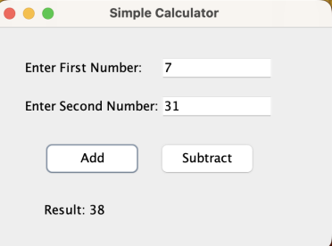

E2=>
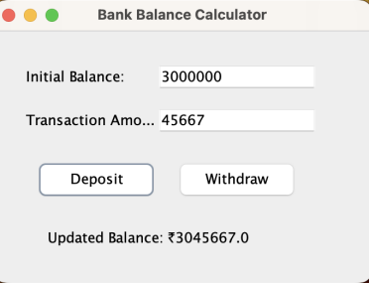
Github  Screenshot | 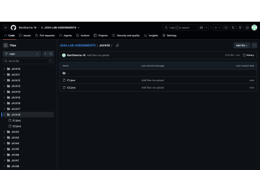
Conclusion | In this assignment, Java Swing GUI applications were successfully developed for a Calculator and Bank Balance Calculator. The programs used JFrame, JLabel, JTextField, JButton, and ActionListener to create interactive applications. Addition and subtraction operations were performed through button clicks, and the results were displayed on the GUI. This experiment helped in understanding GUI components, event handling, user input, and basic arithmetic operations in Java.

